**A**

**PROJECT REPORT**

**ON**

**DOCIFY**

(Online Doctor Appointment Portal)

***Submitted in partial fulfilment for the award of the degree Of***

**Bachelor of Science**

**in**

**COMPUTER SCIENCE**





**Submitted by:**

**Ashish Bhardwaj** 20160272

**Priya Raghav** 20160585

**Pragya Sharma** 20160812

Under the guidance of :

**Mrs. Leena Dhruwa**

Department of Computer science & Engg.

Institute of Engineering & Technology

**MANGALAYATAN UNIVERSITY, ALIGARH**

JUNE,2019

**CERTIFICATE**



This is to certify that this report entitled **“DOCIFY”** by **Ashish bhardwaj (20160272),Priya Raghav(20160585),Pragya Sharma(20160812)** submitted in the partial fulfilment ofthe requirements for the degree **Bachelor of science** in computer science of the Mangalayatan University, Aligarh. During this academic year, 2019-2020 is a bonfire record of work carried out under my guidance and supervision.

**Name of Internal Project Guide: Mrs. Leena Dhruwa**

**(External Examiner)**

**Mrs Leena Dhruwa**

**(HEAD OF DEPARTMENT COMPUTER SCIENCE AND ENGINEERING)**

Institute Of Engineering And Technology

Mangalayatan University, Beswan Aligarh-202145

**ACKNOWLEDGEMENT**



It is a matter of great pleasure for me to submit this report on project entitled “**DOCIFY**”. I have taken efforts in this project. However, it would not have been possible without the kind support and help of many individuals . I would like to extend my sincere thanks to all of them. I am highly indebted to my internal guide for their guidance and constant supervision as well as for providing necessary information regarding the project & also for their support in completing the project.

I would like to express my gratitude towards my parents & teachers for their kind co-operation andencouragement which help me in completion of this project. I would like to express my special gratitude and thanks to my teachers for giving me such attention and time.

My thanks and appreciations also go to my colleague in developing the project and people who have willingly helped me out with their abilities.

Ashish bhardwaj 20160272

Priya Raghav 20160585

Pragya Sharma 20160812

**ABSTRACT**



The objective of this report was to develop an Online Doctor's Appointment in India. The purpose of implementing this application was to create a system through which a patient can easily compare, choose and make an online appointment for a doctor just by sitting at home. The second objective was to replace manual medical file keeping system with online database management system.

The reason behind creating this system was the “trend of private medical clinics” and manual medical file keeping system in India. Online appointment and database management system aims to improve quality medical care by bringing all medical clinics of the city at one platform, eliminating long waiting lines and replacing manual medical file keeping with an online database.

The application was successfully implemented by using famous technologies and programming languages. This application does not aim to target any specific group but every individual who wants to seek medical help and that is why it was kept in mind to keep the user interface simple and friendly while building this application. Like all other applications, this application also has a client side and a server side. This application was developed by using HTML, CSS, and JavaScript at the client side while PHP and MySQL on the server side.

For now, basic functionalities have been implemented but for the future, work will be done to link pharmacies and laboratories to the system. Online follow-up for the distant patients is another feature that is aimed to add at later stages.

**FOREWORD**

I would like to thank my supervisor ’Mrs. Leena dhruwa’ for her guidance and help during my project work.

Ashish bhardwaj

Priya Raghav

Pragya Sharma

June, 2019

CONTENT

|  |  |  |  |  |  |
| --- | --- | --- | --- | --- | --- |
| 1 | 1. INTRODUCTION .............................................................................................................................. | | | |  |
|  | 1.1 | Main Purpose ......................................................................................................................................... | | |  |
|  | 1.2 | Objective of the Project .................................................................................................................................. | | |  |
|  | 1.3 | Aim of the Project .................................................................................................................................. | | |  |
|  | 1.4 | Project Scope ........................................................................................................................................ | | |  |
| 2 | 2.LITERATURE REVIEW .......................................................................................................................... | | | |  |
|  | 2.1 | Introduction .......................................................................................................................................... | | |  |
|  | 2.2 | Domain Research .................................................................................................................................. | | |  |
|  | 2.3 | Technical Research............................................................................................................................... | | |  |
|  | 2.4 | Existing System ................................................................................................................................. | | |  |
|  |  | 2.5.1 | Determination of Problem ............................................................................................. | |  |
|  |  | 2.5.2 | Proposed System ........................................................................................................... | |  |
|  | 2.5 | Patient’s Appointment Time .............................................................................................................. | | |  |
|  | 2.6 | Application Technologies ................................................................................................................... | | |  |
|  |  | 2.6.1 | | Web Server ................................................................................................................... |  |
|  |  | 2.6.2 | | Programming Languages ........................................................................................... |  |
|  |  | 2.6.3 | | Software Tools ............................................................................................................. |  |
|  | 2.7 | Conclusion | | …………………………………………………………………………………………… |  |
| 3 | 3.PROBLEM DEFINATION & REQUIREMENT ANALYSIS ......................................................... | | | |  |
|  | 3.1 System Overview ……………………...……………………………………………………………  3.2 Use Cases ……………………………………………………………………………………………  3.2.1 Patient Use Case ……………………………………………  3.2.2 Doctor’s Use Case………………………………………………… ….  3.2.3 Admin’s Use Case………………………………………………………… | | | |  |
| 4 | 4.DESIGN AND IMPLEMENTATION METHODOLOGY…………............................................... | | | |  |
|  | 4.1 | System Design ................................................................................................................................ | | |  |
|  |  | 4.1.1 | Class Diagram....................................................................................................... | |  |
|  |  | 4.1.2 | ER Diagram ................................................................................................................ | |  |
|  | 4.2 | Identification of choosen Methodology…………………........................................................... | | |  |
|  | 4.3 | Justification to Agile Approach…………………………………………………………… | | |  |
| 5 | 4.4 Description of the system development methodology…………………………………  4.5 Agile Methodology……………………………………………………………………….  4.6 Scrum Implementation………………………………………………………………………………  4.7 Conclusion………………………………………………………………………………………………...  5.RESULT AND CONCLUSION…………………………………………………………… ....... | | | |  |

Future Scope

References

**ABBREVIATIONS AND TERMS**

CSS Cascading Style Sheet

ER diagram Entity Relationship diagram

HTML Hypertext Mark-up Language

JavaScript Scripting programming language

MYSQL Open source database

PHP Server-side scripting language

UI User Interface

XAMPP X-OS, Apache, MySQL, PHP, and Perl

**Chapter-1**

**Introduction**

Health care is one of the fastest growing industry all over the world. Before the last few years, medical appointments were usually taken on the phone calls or by visiting the hospitals in person. This process needed the involvement of individuals so, the ability to take appointment was restricted to the availability of schedulers, phone lines or the physical presence of a person.

With the growth of time, everybody demanded timeless and efficient medical care delivery because manual appointments (that requires the physical presence of both individuals) and long waiting lines have formed an irritating situation for the healthcare institutions. So, it created a need for such an integrated health care system that could deliver seamless care to both outpatients as well as inpatients. The emergence of online appointment system offered timeless and efficient access to health care services. Therefore, for hospitals and other medical societies, online appointment booking has a great importance and a subject of interest (Koole, 2007).

Booking appointment online has become a new trend in the past few years and is considered as one of the key processes in the healthcare industry. Bailey (1952) considered scheduling system as a trade-off or a compromise between a doctor and patient’s waiting times. Patients who get late for the appointments or who fails to come becomes the reason for the underutilization of a doctor’s time. Idle time and underutilization of doctor’s time are also resulted by gaps in the appointment times (Bailey, 1954).

Different researchers agreed that main patient dissatisfaction is caused by long waiting times. Cayirli (2003) defined access time as the time between patients’ request for the appointment and the time he is checked up. According to Veral, waiting time is the time between consultation and the scheduled time while neglecting the early arrival of a patient (Veral, 2003). Different researchers defined waiting /access time in different ways. A well-designed appointment system supposed to improve patients’ satisfaction by reducing cost and time of clinics and hospitals especially in the busy lives we are leading today.

With the growing population need for more efficient ways to access a medical treatment is also growing. Through an online appointment scheduling system, a user gets access to the doctor's online webpage and can make an appointment with online software. Patient/user can also provide additional medical history in advance, giving adequate time to the doctor to prepare the necessary information for consultation. In this way, online appointment scheduling systems are helping doctors and the patients and making the healthcare delivery efficient.

Nowadays there are many kinds of online appointment tools available in the market which are easy to set up and not too much expensive. Online scheduling system offers value-added services and lots of benefits to the doctors and patients. It makes the patient appreciated by eliminating the hassle of long waiting times. Online appointment systems are also getting popular because of its low-cost availability.

**1.1** **Main Purpose**

The main purpose of this project is to link and bring all major private medical clinics of the city (of my country) to a single platform. So that patients can easily get access to the doctor's profile and make online appointments. The second purpose is to create an online medical history database so that doctors and patients can freely exchange patients' medical history information much easier, faster, and safer.

**1.2 Objective of the Project**

The main objective of the thesis is to provide quality medical care to the patients by bringing all medical practitioners of the city to a single platform so that everybody can easily access them and make appointments. The second objective is to replace the current manual file keeping system with an online medical patient database system.

**1.3** **Aim of the Project**

The aim of this project is to create a platform where patients and doctors can access /interact efficiently with each other and provide ease and comfort to the patients. It also aims to resolve the problems that patients have to face while taking appointments and keeping medical files. Patients can choose a medical practitioner based on their professional profile and other patient's reviews. While doctors can access and update a patient’s medical record after every checkup.

Following features will be added in the future:

* Online follow up with doctors (specially for distant patients)
* Linking laboratory and pharmacy so that medical store administrator can view suggested prescription and laboratory can view clinical tests recommended by the doctor. This feature aims to eliminate paper-based prescriptions.

**1.4** **Project Scope**

This system is implemented for all the individuals who want to get treated by the city practitioners. The users can participate only if they have created an account through the registration form and have provided their medical history. Once they get registered themselves further they would not need to update their record as it would be done automatically after each doctor’s visit.

**Chapter-2**

**Literature Review**

2.1 Introduction

Appointment scheduling has become a complex task especially for healthcare professionals in hospitals and clinics. Few reasons that could cause these complications range from a heavy flow of patient traffic to a physician that practices in a number of clinic and moves from one medical facility to others. An ineffective appointment management could also cause overlapping appointments, rise in number of no-shows, patient dissatisfaction in general and revenue loss for healthcare institutions.

In recent days, many medical institutions use a combination of phone-based scheduling and computerized appointment scheduling. Even though this combo along with out-sourcing services make a better efficient system, few gaps for technical and human error still remains.

This online facility is an effective add-on to any hospital or clinic’s website. It lightens the hard work associated with managing a medical facility. More time on hand to commit to patient care, better patient compliance and fiscal viability are other rewards. (NIMS Institute of Management & Computer Sciences, (n.d))

The key mission of an efficient online patient scheduling is to reflect patient satisfaction and revenue gains. An active appointment scheduling a bridge that connects efficient healthcare services and timely access to the services. The proposed Patient Scheduling system aims to even out workflow and reduce the thronging of people in waiting rooms.

Any medical center that handles patients’ scores and healthcare responsibilities are at risk of wasting too much time and money on patient scheduling. Especially small size clinic where physicians manage their own medical office, it is not worthwhile to continue with primitive paper based scheduling system. Since appointment books are limiting and time consuming, the more cancellations and scribbles the more this process confuse and frustrate the staff who are managing these. In comparison to paper-based appointment scheduling, web-based patient scheduling is faster that allows multiple user access at any given time. Web-based appointment scheduling enables to generate appointment reports and email appointment reminders and minimizes no-shows.

2.2. Domain Research:

**Outpatient Management:**

The combination of time, technology and the rapid increase in population has been the drive force to introduce an online patient scheduling. Outpatient management is one key factor that has been influential for developing an online appointment system. Outpatient services have become an essential component of healthcare industry. The objective of outpatient scheduling is to provide an appointment system service that measures optimized performances in a clinical environment.

* **Waiting Time:**

Long waiting times are an alarming problem for patients using urban health centers in developing countries. According to a case study conducted for NHIS Outpatient in Nigerian teaching hospitals, a bock appointment system was introduced and evaluated in a large South African health center. Waiting times of patients were measured over one-week period during the research before and after the implementation of appointments. Groups and individual interviews were conducted with management staff and patients. After launching the appointments system, patients with acute and chronic illnesses and having appointments had significantly shorter waiting time than similar patients without appointments. (Idowu, A., Adeosun, O. and Williams, K. (2014))

Research carried out based on patient health care service requirements appointment could be divided into three major sections such as Primary Care Clinic, Specialty Clinic and Surgery Appointment Scheduling. (Gupta & Denton, 2008)

* **Primary Care Clinic Appointment:**

This section falls under the initial care fields that are provided by a single physician or a group of physicians running a medical facility. One prime example under this section is small size clinics. For wider scale clinics running by multiple physicians and multiple departments, patients prefer time slots and physicians’ availability. Efficiency in clinic and patient satisfaction could be improved by assigning a patient to a preferred time slot and a physician who is familiar with the patient’s medical issues. The number and length of available appointment time slots are settled based on the type of service request, medical urgency and provider’ panel.

* **Specialty Care Clinic Appointment:**

This section focuses on diagnoses, treatment and recovery for certain specialties such as neurosurgery, cardiology, and Endocrinology etc. particular related tests could be provided to

complete the diagnoses. Sometimes specialists require a referral from a primary care physician for patients’ first appointment. The length of available appointment time slots are fixed for these services and the availability for examination facilities such as X-rays, Scans are taken into consideration.

**Considerations of Patient Scheduling:**

The major aim of patient scheduling is to provide an optimal policy and to gain a positive balance between patients’ satisfaction and the performance of medical institutions. Generally certain factors influence on the performance of an appointment such as urgency of patients, punctuality, no-shows and cancellations and service processes. These criteria are taken a base line while developing a well-designed web-based appointment system. (Cayirli & Veral, 2003).

* **Unpunctuality:**

Difference between patient arrival time and actual appointment time lead to a dysfunctional clinic management. Nuffield Trust studies (1955) implied that more than half of 8 the patients arrive early, which could cause the congestion of the patient’s waiting room and increase patients’ waiting time. Wijewickrama & Takakuwa (2008) discussed how the impact of no-shows on patients’ waiting time is higher than that of punctuality. Moreover, some studies also show, the impact of physicians’ unpunctuality where the physician caused delay for the appointment. Vissers (1979) pointed out patients’ waiting time and physicians’ idle time were affected by the unpunctuality of both patients and physicians.

* **No-show and Late Cancellations:**

This section prioritized who are late and miss their appointments. This results in no-show problems that increase under-utilization of clinic capacity. Generally, 5-30% is used as a no-show probability in past studies (Ho and Lau, 1992 & 1999; Klassen and Rohleder, 1996; Yang, Lau and Quek, 1998; Cayirli, Veral, and Rosen, 2006 & 2008; Kaandorp and Koole, 2007). Certain papers analyzed real data from clinics and pointed out that patients with relatively high no-show probability are younger, male, unmarried, uninsured, with psychosocial problems, of lower socioeconomic status, divorced or widowed and have a history of missed appointments (Neal, Hussain-Gambles, Allgar, Lawlor, and Dempsey, 2005). Daggy et al. (2010) pointed out transportation and appointment lead time affected the no-show probability as well.

Some papers implied that long appointment lead times increase the no-show rate. Dove and Schneider (1981), Lee et al. (2005) and Gallucci et al. (2005) reported that no-shows were the most influential factor on performance of Appointment Scheduling among three environmental factors reviewed (Ho and Lau, 1992). To reduce no-show probability, changing patient behavior or applying overbooking and short lead-time scheduling are suggested. (Daggy, etal. 2010)

* **Patient Preference:**

Few case studies states that accommodation of patients’ preferences could help to ensure the quality of services provided by primary clinic physicians and increase clinics’ revenues. (O’hare and Corelett, 2004) No-show rates could also be reduced if patients’ preferences are matched.

* **Arrival Characteristics:**

Size of arrival units are important for clinic-patient management success. A single arrival is taken as only one unit, the smallest number handled that arrive at the system and wait for services. This is typically a single patient.

A group arrival is said to be several unit entering the system at the same time. In such scenario, the time between successive arrivals of the groups could be probabilistic as well as the number of patients in the group. (Dai, X. (2013))

* **Service Characteristics: Number of Services:**

There are two types of queuing process for the number of service provided by any medical center. Single stage queuing means when only one type of service is requested at the patient arrival. Multi stage queuing refers to a series of branched services that are requested in the whole service process.

**Number of Physicians:**

According to queuing theories, queuing system are two kinds: single server and multiple server systems. In a doctor-patient scenario, physicians are servers. In primary multi-physician clinics, doctors have their own panels as a result, patients are able make appointments to different physicians based on their different specializations. In such cases, appointment systems are multi-server systems. When studying the performance of an appointment system, multi-server systems are taken into consideration in some papers such as Wijewickrama & Takakuwa, (2008) and Chao et.al (2003).

**Service Time:**

Service times could be random or constant. Majority of the time, it could be assumed that the service time of routine appointment at primary care clinics is constant.

**Queue Discipline:**

This process determines the priority order for patients to be scheduled for an appointment. According to general queuing theory, queue discipline is divided into four main classes, first come, first serve, last come first served, service in random order, and priority ranking. In the appointment scheduling problem, it is assumed that patients are served FCFS in most of papers. In the real world, some clinics apply a priority ranking discipline when they scheduling appointments. For example, clinics give the first priority to emergent patients and second priority to readmission patients. Walk-in patients are usually given to the lowest priority. (Dai, X. (2013))

**Measurements of an Appointment System Performance:**

A case study provided by Cayirli and Veral (2003), patient scheduling’s performance are measured according to patients’ waiting time, providers’ overtime and idle-time and cost of the management.

* **Cost-Based:**

There are three factors that are to be considered: cost of patients’ waiting time. Physicians’ idle time and overtime. In most of cases, costs of patients’ waiting time and physicians’ idle time are the main considerations, such as in Vanden Bosch, Dietz and Simeoni (1999), Lau and Lau (2000), Robinson and Chen (2003). Few of studies focus on minimizing appointment cost based on these three factors.

* **Time-Based:**

The three factors mentioned above are measured in terms of mean, maximum, variance and frequency distribution. Patients’ waiting is the difference between the scheduled appointment time and patients’ actual service time and waiting time due to early arrival is not counted. Doctors’ idle time defines the waiting time caused by no patients waiting to be seen. Overtime is the difference between actual and planned finish time of consults. O’Keefe (1985), Walter (1973), Vissers and Wijingaard (1979) have submitted papers on appointment system problem with time-based measurements.

* **Fairness:**

Fairness is measures by the uniformity of performance of a patient scheduling system. By evaluating the mean waiting time of patient according to their place in the queue (Bailey, 1952), variance of waiting time and queue size (Blanco Whit and Pike, 1964, Fetter and Thompson, 1966, Yang, Lau and Quek, 1998), any patient scheduling system’s fairness is determined.

* **Developing Algorithm:**
* After a gathering a brief understanding on the issues and factors mentioned above, the final phase is to develop an algorithm for the proposed patient scheduling system.
* Robinson and Chen (2003) tried to balance waiting time and idle time using Monte Carlo integration, solved the problem approximately as a stochastic linear program and developed a theoretic closed-form heuristic policy. Mancilla and Storer (2012) developed a stochastic scheduling problem considering waiting and idle time and overtime cost for operation room and surgery scheduling. A multi-stage stochastic integer program using sample average approximation was applied to solve this problem.

2.3 Technical Research:

During this stage of research, more technical information and requirements are gathered about the proposed system.

**System Requirement Analysis:**

For any software development, the initial phase is to conduct a demand analysis. Demand analysis is the process of discovery, refinement, modeling, specification and review. The process is directly related to the quality of the software and subsequently studies significant impacts on the design and implementation. For this analysis, functional requirements and technical requirements are analyzed.

* Another way of gathering system requirements is to analyze the Demand versus Capacity study. This study helps to understand whether the right number of appointments are offered, the suitable mix between same-day and pre-bookable and to check whether these components are spread correctly across the week. (Improving access, responding to patients. (2016))

**Functional Requirements:**

Based on the research conducted for the proposed system, there are two sets of functions for an online appointment system. The first set of functions is online registration including sign up and log in, selection of department, date, physician and other online booking registration functions.

* 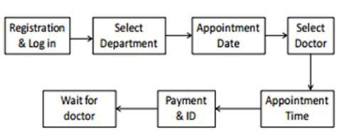

The next set of functions is data management that allows the database administrator to add, delete, modify and back up the data. Data addition, deletion and modification are the basic functions that are to be effectively maintained the consistency of the database to meet actual requirements. Data restore and back up are the system’s security enhancer.

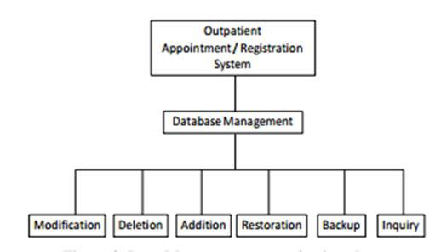

**2.4 Existing System**

In India, there is a huge trend of private medical clinics and hospitals. Doctors run their own private clinics and consult patients during the evening or any time of the day depending on their availability. Some are popular and known to all while some are known by few people. This situation proves to be a challenge for new practitioners as they are known to very few people even if they have a good academic background. On the other side, patients also face difficulty in finding and choosing a nearby doctor. Unscheduled appointments, long waiting lines and keeping medical files in physical form are also the common problems faced by the people/ patients of India.

**2.4.1** **Determination of Problem**

**Challenge for new practitioners**

Starting a private clinic can be a challenge for new practitioners. For example, if a new doctor wants to open his clinic there is no platform exist, by which or from where people can get to know about his clinic.

**The problem for a new individual in a city**

In the same way, the same problem goes for any person new to the city as he is unknown, who is the best or closest doctor/clinic to go for a medical checkup.

**Long waiting lines**

To get doctor's consultation, patients come twice to the clinic once for taking the appointment and second time for the checkup. Some patients visit the doctor without any prior appointment resulting in a long waiting time. There is also a possibility that they don't consultation by the doctor even after a long waiting line.

**Managing paper-based medical files**

Patients must carry their medical related report or files every time they visit a doctor. And sometimes they lost their files too.

**2.4.2** **Proposed System**

In “**DOCIFY**” I have tried to consider all of the above problems with the existing system in India. My objective was to provide a platform where all practitioners and patients can be brought together. In this application, all practitioners either new or working for a long time can sign up themselves. This way people can get to know and choose to visit any doctor of their choice. By using this application user will be able to know and access the professional profile of each registered doctor from all specialties. Doctor’s profile includes information regarding their professional experience, practicing license, educational background, clinic timings, working days, clinic accessibility and other patient reviews also. Users would be able to book appointment sitting at their homes. The user can choose a doctor close to them or have more professional experience or have more good reviews from the other patients. New practitioners can easily join the platform and start taking appointments without the need of any expensive advertisement.

When registering as a patient, the user can give all necessary medical history so that he doesn't need to keep or bring his medical file when going for a check-up. Every time

when a user books his appointment, the doctor can easily get access to the patient’s profile and also update medical record.

**2.5** **Patient’s Appointment Time**

Scheduling appointments for the patients started long years ago. Primarily appointment system was developed to minimize doctor’s idle time because it was thought that doctors time is more valuable as compared to the patient’s waiting time. But later it was realized that the importance of minimizing the patient's waiting time is as important as the doctor’s time. So now while developing an appointment system doctor's idle time and the patient's waiting time both factors are given equal importance. Patient’s scheduling also includes improving quality health services, reducing doctors and nurses idle time and reducing patient’s waiting time.

**2.6** **APPLICATION TECHNOLOGIES**

The purpose of this project is to build an Online Appointment and Database Management System. It is important for the user to understand how this application works and knowing the technologies that are used to implement this project. For a better understanding, all steps are described in detail to give a full overview of the system.

**2.6.1** **Web Server**

Role of a web server is to communicate between the client side and server side by storing, processing and delivering web pages to the client side. Usually, web browser initiates the communication using HTTP by sending the request of a specific resource and server gives the response with the content of that requested resource. For this project work, Apache HTTP server was chosen, and it exists on the WAMP service. Apache HTTP server is one of the popularly used web server software used in a lot of project works.

**Apache web server**

Apache web server is a free, open source and most popularly used software. Apache web server is used by many famous websites such as Apple, Wikipedia, and PayPal. Another reason for its popularity is that it can run on multiple operating systems such as Linux, UNIX, windows, and macOS. Another feature of Apache web server is that it can host websites which use server-side language code (Perl, PHP). Because in this project server-side implementation is done by using PHP so Apache was a good choice.

**2.6.2** **Programming Languages**

In this project, PHP was chosen as a server-side programming language and MySQL was selected as a backend database. HTML, CSS, and JavaScript were used for the client-side work.

**PHP**

PHP is a server-side programming language commonly used to develop dynamic web pages. It is free and accessible in numerous different versions. It can be used on multiple OS such as macOS, windows, UNIX and different platforms. Because it is a scripting language so in this program code is taken after the program execution. PHP can also be used in desktop applications.

One of the reasons for choosing PHP in this project is that it supports MySQL which is chosen as a database in our project. PHP programming language makes easy to present images and PDF files on HTML pages.

**Client-side programming**

For the development and designing of web pages HTML, CSS and JavaScript languages were used. HTML for creating the web pages, CSS for styling and for adding further functionalities JavaScript was used.

**JavaScript**

JavaScript is dynamic, high-level scripting language and considered to be one of the core three technologies of the world wide web. It is considered an important part of a web application. It is used for adding functionalities and making web pages interactive. In simple words, it informs the browser about a certain activity or event that occurred and changes the web page as a response to that event, for example, a click on a button.

**HTML**

Hypertext markup language (HTML) is used for creating web pages and web applications. It describes the structure of the web pages. Information from the HTML documents is sent to the web browser to render or display on the multimedia pages. Html used to describe the structure of a document by presenting a document in a heading, paragraph, image, list, links and other objects like that. Web browser presents the HTML document by using its tags.

**CSS**

It is important to make HTML pages attractive to the users and for this purpose, developers choose colors, nice fonts, and different layouts. All this work is done by the CSS. In short, CSS is used for styling of a HTML document. It is designed in such a way that enables separation of content and presentation so that it makes easier any change of

content without interfering with a design. It also enables multi web pages to share the single CSS file for styling to reduce repetition and complexity.

**Backend technology**

For this project work, MySQL was chosen as a database.

**MySQL**

It is an open source relational database management system which aims to offer multiple user access to several databases. In simple words, a database is a collection of data which can be a list of shopping items, number of items in a shopping centre or even a vast amount of numerous data in a corporate network. To manage such kind of data, a database management system is required such as MySQL which aims to access data and perform functions like add, remove or edit data. Since MySQL is a relational database so it stores data in different tables instead of putting into a large storeroom. Storing /organizing data into tables increases the accessibility speed and flexibility.

Applications which demand availability and scalability use MySQL. Because it has the capability to recover and cope with failures on the host, MySQL, operating system or the hardware that may cause downtime. Scalability refers to the ability to spread the database as well as application queries. MySQL is reliable for data security. MySQL has a good memory management system and provides multiple development interfaces (ODBC, JDBC).

Since MySQL is a free open source software so anyone can download it without paying anything and make changes into the source code. For this project, MySQL was chosen because it is very easy to use and PHP's ability to work with MySQL.

**2.6.3** **Software Tools**

For this project work following source tools were chosen to perform various tasks:

**Notepad++**

Notepad++ is an unrestricted, plain text editor used widely by developers for Microsoft Windows. Notepad++ supports several languages and is used to write and edit code. In this project Notepad++ is used to write HTML, CSS, PHP and JavaScript codes. Its main features include syntax highlighting, correcting and auto-completion.

**XAMPP Server**

XAMPP is a free and open source software which empowers technologies, processes, and machines to link and work together. It is established by Apache. It stands for x-OS, Apache, MySQL, PHP, and Perl and used as a stage for coding and designing web pages.

Xampp is very easy to install and has the capability to run on several platforms. Xampp has very strict security settings and with a single command it can start and stop the server.

2.7 Conclusion

The adaptability of an online patient scheduling structure enhances services provided by medical institutions. This is a great way of assembling all the appointments from website. It delivers flexibility and simplicity to patients, that’s the reason online appointment systems are becoming popular these days. During the research process, various articles and similar systems have been analyzed. Based on the content found during the research, a new Online Patient Scheduling System has been proposed in the following chapters.

**Chapter -3**

**Problem Definition & Requirement Analysis**

The system architecture of this system is divided/split into two parts. One is the client side and the other is the server side. Client-side is the user interface whereas the server side is the combination of web pages written by PHP and the MySQL database. PHP pages contain the written SQL queries which make the accessibility to database possible. The following figure shows the architecture of the system while the detail of the technologies used in this application is discussed in chapter 2.

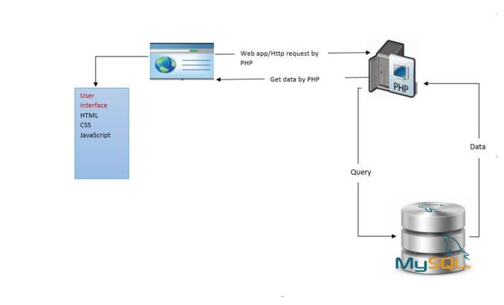

**3.1 System Overview**

We are implementing a web-based appointment system in India for booking an online appointment and keeping an online medical history. Users can sign up online, search for the nearby doctor and book appointment while sitting at their homes by using a web browser. Two different types of actors are using this system: user actor (patient), which can be registered to the system, search for the doctor and book an appointment. Administrative actor (doctor/ physician), which can log in to the system with a username and password, accept patient's appointment request and update medical record after each visit. The functionality and more features are explained in more detail in this chapter.

The main characteristics of the system are:

Every individual either a doctor or a patient will have an independent id, name and a profile’s.Doctors are further categorized by the specialty of practice (i.e. Obs/Gyne, Urology,Internal Medicine etc.)

The user (patient) can get, change or cancel appointment time and view medical record while the doctor can make changes in his calendar and accept or reject appointment request by log in to the site and accessing his/her personal page.

**3.2** **Use Cases**

To explain the better view and functionalities of the system, use case diagrams are chosen. The use case diagram is important to document the requirement of the system as well as to specify functionalities of the system. Use case diagrams better explain the way the user interacts with the system.

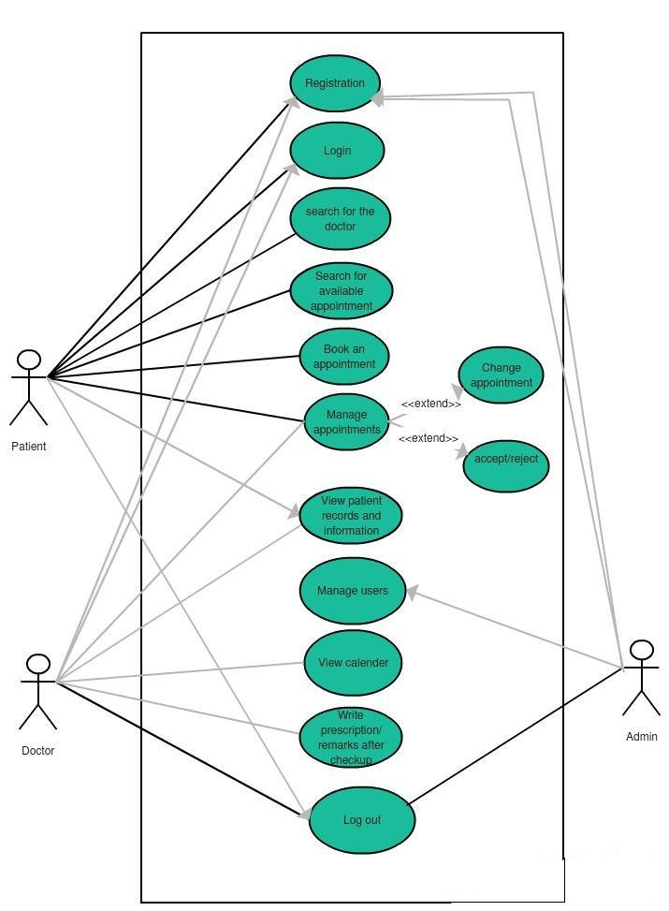

**(Figure 1: Use Case for Diagram)**

**3.2.1** **Patient Use Case**

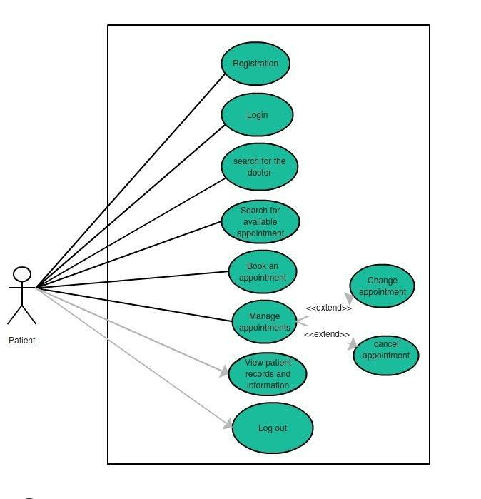

**(Figure 2: Use Case for Patient user)**

**Use-Case 1: Registration**

**Primary-actor:** generic user/patient.

**Description:** To make an appointment, user registration is required.

**Precondition:** National ID card and valid email address.

**Basic use-case flow:** For the registration process, the user/patient needs to give some

information by filling the form. Some of the required information includes the following:

First name

Last name

Gender

Email address

National ID no.

**Main scenario:** The user/patient will go onto the patient sign-up button either from themain page or from the drop-down menu. After clicking the sign-up button, a registration form will appear, where the user must give his personal information i.e. name, gender, email address, CNIC, any medical history etc. After giving the required information user will submit the form. If all the fields are filled including the valid email address and CNIC, the user will be registered onto the system. In case of any missing entry or invalid format of an email or CNIC, the error occurs onto the page.

**Exception:** Expired/invalid National ID card no or email address.

**Use-case 2: Login**

**Primary-actor:** Patient/user.

**Description:** Before taking any appointment or get access to his medical record, the usermust have to provide his username and password.

**Precondition:** the user must have a valid username and password.

**Basic use-case flow:** a valid username with a password must be entered by the user.

**Main scenario:** To be able to get into the system, the user needs to enter his usernameand password either from the main page or from the drop-down menu from the top of the page. After clicking onto the login button, authentication request will be forwarded to the system.

**Exception:** wrong/invalid entered username or password.

**Use-case 3: search for a doctor**

**Primary-actor:** User patient/generic user

**Description:** In this use-case, any registered or unregistered user, can look and search fora doctor of any desired specialty.

**Precondition:** this use-case has no exception.

**Basic use-case flow:** By going into the category of any specific specialty, the user canview the list of all registered doctors.

**Main scenario:** The user will go to the down menu at the top of the page. A list of allspecialties will appear in a drop-down list. The user will hit on the desired specialty. After that, a page will open with all doctors of that specific specialty. Now the user has the choice to choose any doctor based on qualification, experience, location etc.

**Exception**: no exception for this use-case.

**Use-case 4: Take Appointment**

**Primary-actor:** User/patient

**Description:** After choosing a doctor user will go further to send an appointment requestfrom the available timings.

**Precondition:** the user must be login

**Basic use-case flow:** The patient/user hits the button for taking an appointment for thedoctor. A list of available timings will appear for the chosen date. The user will select the suitable time for him and send the request for approval.

**Main scenario:** The user will hit the button for "take appointment". List of availabletimings will appear for a chosen date. The user selects the suitable time. The user will hit the submit button to send the request for approval.

**Exception:** this use-case has no exception.

**Use-case 5: View history**

**Primary-actor:** User/patient

**Description:** the user can view his medical history.

**Precondition:** the user must be signed in.

**Basic use-case flow:** The user/patient will click on the name of the patient and it opensthe patient's profile. By going into it the user can view the history by clicking on the button for the patient’s old reports/history.

**Main scenario:** The user clicks on the name of the patient and then press the button“viewhistory” to view old reports.

**Exception:** no exception for this use-case.

**Use-case 6: Log out**

**Primary-actor:** User/patient

**Description:** the user will log out from the system.

**Precondition:** the user must be logged in

**Basic use-case flow:** the user can sign out himself from the system.

**Main scenario:** the user clicks on the log out button. The system will bring the user tothe main page for the generic user.

**Exception:** no exception for this use-case.

**3.2.2** **Doctor’s Use Case**

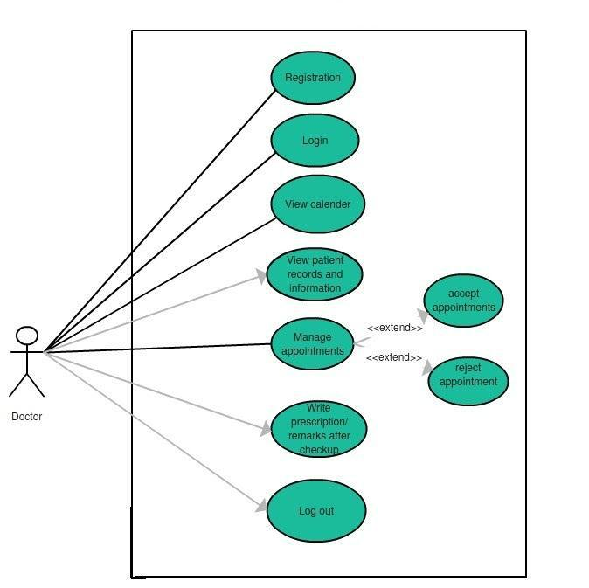

**Figure 3: Use Case for Doctor (user)**

**Use-case 1: Registration**

**Primary-actor:** Generic user/doctor

**Description:** To get online appointment requests, the doctor must register himself as auser on the application/system.

**Precondition:** National ID card and active email address.

**Basic use-case flow:** To register as a doctor, the user must fill the form. Required fields

include the following information:

Full name

Email address

National identity number

Qualification

Experience

Valid PMDC certificate (Practicing license issued by the PMDC authority)

Clinic address

Clinic timings

**Main scenario:** The user/ doctor has to go onto the doctor’s sign-up button either fromthe drop-down menu at the top or from the main page. After clicking the sign-up button, a registration form will appear, where doctor/user has to give his personal as well as professional information i.e. name, clinic address, qualification, working experience etc. The user must give valid PMDC certificate for the registration process. After giving the required information user/ doctor will submit the form. If all the fields are filled, request for registration will be sent to the admin. As soon as admin receives a request for a doctor's registration he will verify his documents and only then the user will be accepted /registered. In case of any missing entry or invalid format of email or CNIC, an error occurs onto the page. PMDC certificate is a license or a proof that an individual is allowed by the authority to practice medicine. Any user fails to give valid PMDC certificate issued by PMDC authority will not be allowed to register as a doctor. PMDC certificate is important to avoid any scam.

**Exception:** False documents, expired or invalid PMDC certificate, missing fields,expired national ID card or inactive email.

**Use-case 2: log in**

**Primary-actor:** User/doctor

**Description:** For further functions, the user must have to provide his email address andpassword.

**Precondition:** the user must enter the username and password.

**Basic use-case flow:** user/doctor should provide his username and password to log in.

**Main scenario:** To be able to get into the system, the user needs to enter his usernameand password either from the main page or from the drop-down menu from the top of the page. After clicking onto the login button, an authentication request is forwarded to the system.

**Exception:** occurs if fails to provide username and password.

**Use-case 3: View calendar**

**Primary-actor:** User/doctor

**Description:** User would be able to view his calendar.

**Precondition:** The user must be signed in.

**Basic use-case flow:** After logging in, the user/patient selects the date from the calendarto filter out the appointment.

**Main scenario:** After signing in, the user/doctor can view the page of his calendar. Theuser will select the month and date to see the appointments of that period or date. The user can view all the patient's appointments of any date.

**Exception:** no exception for this use case.

**Use-case 4: Accept or reject a request**

**Primary-actor:** User/doctor

**Description:** User/doctor can accept or reject any patient's request.

**Precondition:** User/doctor must be signed in.

**Basic use-case flow:** User/doctor selects any date and decides to accept or reject anyappointment request.

**Main scenario:** After logging in, all the patient's appointment requests will be appearingon the calendar according to the dates. User /Doctor will select the date from the calendar. User /Doctor can view all the appointment requests. User /Doctor can select the option to accept or reject the appointment request from the drop-down menu.

**Exception:** no exception for this use case.

**Use-case 5: View patient**

**Primary-actor:** User/doctor

**Description:** User/doctor would be able to view the patient's detailed informationincluding his/ her medical history.

**Precondition:** User/doctor must be signed in

**Basic use-case flow:** After selecting the date, user/doctor selects the patient. User/doctorcan view the patient's detail and medical history.

**Main scenario:** After selecting the date, list of patients of that particular date will appear.User /Doctor will select the patient. User (doctor) can view his all information including the medical history by clicking on the "view patient" button

**Exception:** no exception for this use case.

**Use-case 6: Add comments**

**Primary-actor:** User/doctor

**Description:** User/doctor would be able to write his own comments into the patient'smedical profile.

**Precondition:** User/doctor must be signed in

**Basic use-case flow:** After clicking on the "write comments" button, user/doctor can addhis own reviews after checking the patient.

**Main scenario:** User/doctor will hit the "write comments" button. User (doctor) willwrite his or her comments. User/doctor will hit the submit button.

**Exception:** no exception for this use case.

**Use-case 7: log out**

**Primary-actor:** User/doctor

**Description:** the user/doctor will log out from the system.

**Precondition:** the user/doctor must be signed in

**Basic use-case flow:** the user/doctor can sign out himself from the system.

**Main scenario:** the user/doctor clicks on the log out button. The system will bring theuser to the main page for the generic user.

**Exception:** no exception for this use case.

**3.2.3** **Admin Use Case**

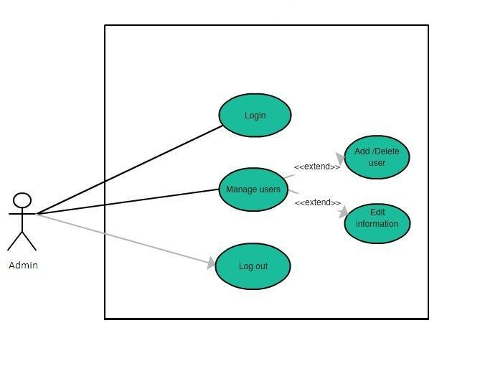

**Figure 4: Use Case for admin**

**Use-case 1: Login**

**Primary-actor:** Admin/administrator

**Description**: A user, who possesses admin username and password, owns administrativerights.

**Precondition**: username and password.

**Basic use-case flow:** Admin/user needs to provide the username and a password.

**Main scenario:** Admin/user enters valid username and password. After verification, theuser will be logged in as an admin and can use all the administrative rights.

**Exception:** occurs if user provides wrong username/password.

**Use-case 2: Manage users**

**Primary-actor:** Admin/user

**Description:** User/admin can use his administrative rights.

**Precondition:** the user must be logged in as an admin.

**Basic use-case flow:** Admin/user can view, edit or delete any user information.

**Main scenario:** Admin can view, edit or delete any user or any information related touser doctor or user-patient.

**Exception**: no exception for this use case.

**Use-case 3: log out**

**Primary-actor:** Admin/user

**Description:** Admin will log out from the system.

**Precondition:** Admin must be signed in

**Basic use-case flow:** User signs out himself“as an admin".

**Main scenario:** User clicks onto the logout button. The system will remove informationfrom the local storage and brings the user to the homepage.

**Exception:** no exception for this use case.

**Chapter-4**

**Design & Implementation/Methodology**

**4.1** **System Design**

**4.1.1 Class Diagram**

The class diagram is chosen to explain the design phase of the system. A class diagram describes classes of the system, attributes, and operations and relationships of the classes in a better way. We can also say that class diagrams are used to justify the structure or behavior of use cases of the system. Class diagrams best explain the conceptual model of the system in terms of entities and their relationships. The class diagram looks like a shape of a rectangle, comprising three compartments stacked vertically. The first top box comprises the class name, the second middle box contains the attributes of the class and third the last box contains the methods or functions performed by that class. The first compartment /box of the name is compulsory while rest of the two can be omitted to simplify the diagram. So, in any class diagram first compartment must be drawn while the second two compartments are optional.

The class "patient" contains multiple parameters (such as id, name, age, address), which depict the information of all the registered patients. The user class also contains the methods performed by these users such as get appointment, view/ create own medical record etc. In the same way, the class "doctor" has the parameters id, name, department, address possessing all the required information of the users registered as a doctor on to the system. Methods include accept/reject the appointment, check the patient, view a medical record of any patient etc. These methods are the functions performed by the users registered as a doctor on the system. The class “appointment” has the parameters of date and time, explaining what time or day patient user has requested for the

appointment to the doctor. The class “department” has the parameters id and name and methods include add/ delete doctor and add or delete department. Every doctor user must belong to any department class. The “report” is another class containing methods like write report or prescribes medicine. In the end, class “admin” contains the parameters like id and name and methods of this class include manage users.

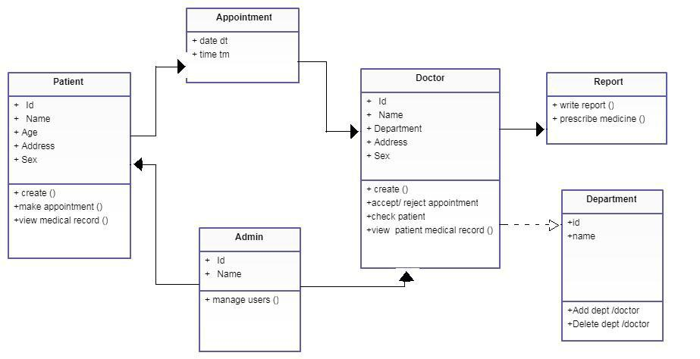

**Figure 5: Class Diagram**

**4.1.2** **ER Diagram**

A basic ER model consists of objects called entities and specifies relationship among those entities. Purpose of this diagram is not to define any functionality rather show association and dependency among entities. ER diagram is drawn with "rectangular boxes" as entities and the "straight lines" showing the relationship between these boxes. An entity is an object or a thing that has an independent existence and can be easily differentiated from others. Each entity has some attributes like name, age, address, department etc. In the following diagram the doctor, patient, appointment, admin etc, all are different entities. So, an entity can be a person, animal, plant, event or a company.

Entities consisting of similar attributes make the entity sets. These entities have some association among each other which make a relationship. These relationships can be "one to one" or "one to many" or "many to many". For example, a doctor and department can have "one to many" relationships, means one department can have many doctors but one doctor is related to only one department.

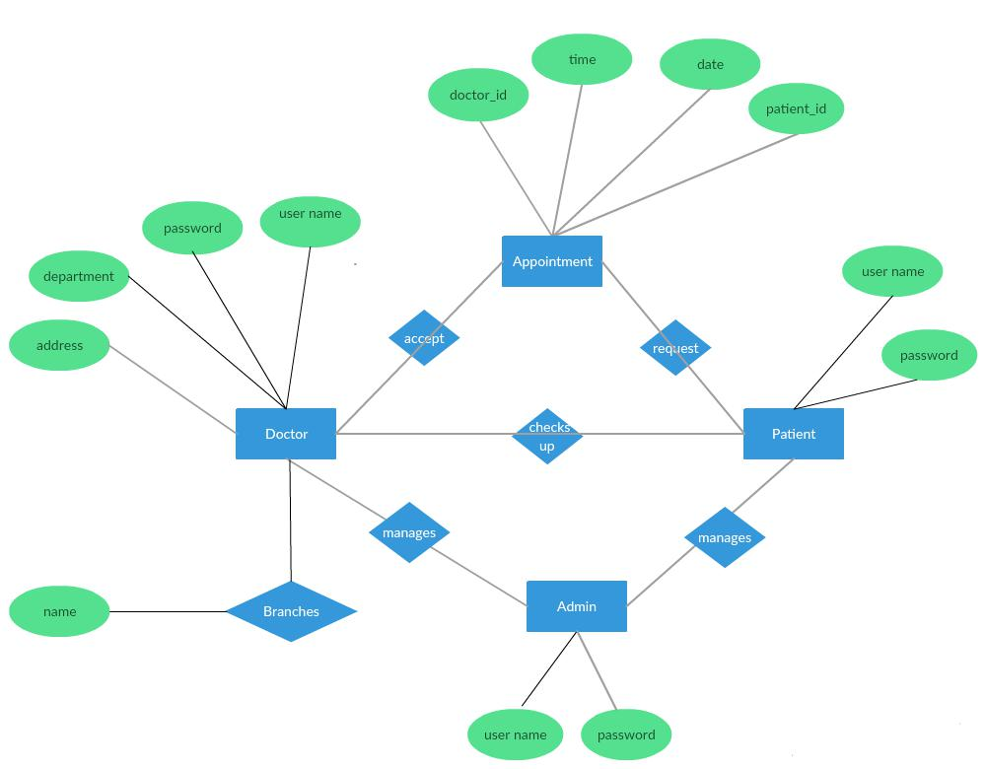

**Figure 6: ER Diagram**

4.2 Identification of Chosen Methodology: Agile

During a system development lifecycle, there are two main factors that are considered: to emphasize on process and the quality of the software and process itself. (Sharma, S., Sarkar, D. and Gupta, D. (2012)) Since software development is a complex filed that contains countless variables impacting the system, any develop would always seek for an organized structure that could be used as a base for developing a system. All software systems are imperfect because they cannot be built with mathematical or physical certainty. Thus, system development methods are introduced in order provide developer a base line of processes and sequences to follow while building a system.

Different software developing methods have different characteristics of processes to reach completion of a system. Based on the research carried out and analysis of system requirements for the proposed Online Patient Scheduling System **Agile Method** is selected by the developer. In general terms, Agile process is an iterative approach that prioritizes customer satisfaction and customers have direct involvement evaluating the software. Agile method follows the Software Development Lifecycle that includes requirement gathering, analysis, design, coding and testing. As a result, the approach delivers a partially implemented software and waits for customer feedback.

4.3 Justification to Agile Approach

Agile Method is programming centric. While other methodologies are mainly based on the premise that software development processes are to be repeatable thus predictable, Agile framework emphasizes on unit-by-unit development.

The aim of Agile Method is to allow organizations to be agile in terms of delivering the product quickly. Agile approach is a combination of group of methods. While Agile techniques vary in emphasis and practices, they have common characteristics including iterative development and focus on interaction, communication and the resource-intensive intermediate artifacts. (COHEN, D., LINDVALL, M. and COSTA, P. (2004))

One of the key reasons why the developer chose Agile Methods for the proposed system is that Agile approach is able to identify and respond to changes more quickly than using project using a traditional approach.

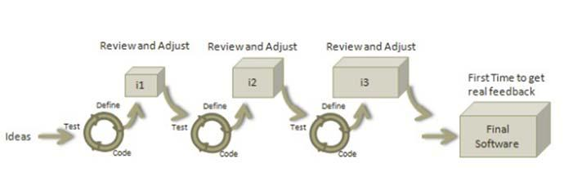

**Figure : Agile overall Process. (www.tutorialspoint.com, (2016))**

While selecting a development methodology for the system, Agile method was the developer’s first choice because Agile process requires less planning and it divides tasks into small increments. Following this approach while developing the Online Patient Scheduling system would allow the developer to make necessary changes according to user satisfaction.

4.4 Description of the System Development Methodology:

Agile development methods break a problem into smaller tasks. The processes do not require direct ling-term planning for any requirements. Agile method provides modularity to the system. It decomposes the complete system into manageable pieces called modules. Modularity is an important role in software development. Following Agile process would allow the developer to plan iterations that are of short period of time such as one to four weeks. Since the project is an individual final year project, the developer herself would conduct each iteration that works in all functions of software development such as planning, requirement analysis, design, coding, unit testing and acceptance testing. As agile method is iterative in nature, it requires time limits on each module with respective cycle, thus providing the developer with sufficient time window to work on each module. The process produces increments and each increment in independent of others that would allow the developer to integrate all the increments into complete system. Agile approach is adaptive. The adaptive nature of the method would allow the developer to design the system in an order that would adapt possible risks on its way to development.

4.4.1 Agile Manifesto

Agile methods stress productivity and values over heavy-weight process overhead and artifacts. (Szalvay, V. (2004))

Agile Manifesto is a combination of agile software development methodologies. In 2001, founders of many agile system development methods gathered with others who were also implementing various agile methods in the same field and created ‘Agile Manifesto’.

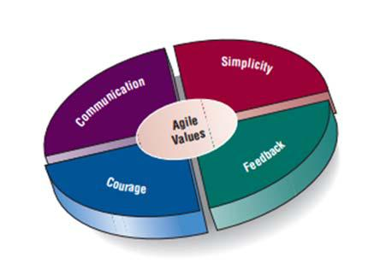

**Figure : Agile Manifesto Model. (AGILE MODELING AND PROTOTYPING. (n.d.))**

The Agile Manifesto addresses features such as, individuals and interactions over processes and tools, working software over comprehensive documentation, customer collaboration over contract negotiation and responding to change over following a plan. The Manifesto stands on twelve basic principles that states:

* **Customer Satisfaction:**

Maximum priority is given to satisfy the users’ requirements through early and continuous delivery of valuable software.

* **Welcoming Changes:**

Changes are inevitable during any system development. Ever-changing requirements are to be welcome, even late in the development stage. Agile processes work to increase users’ competitive advantage.

* **Delivering a working software:**

Delivering a working software frequently, ranging from a few weeks to a few months, considering shorter time-scale.

* **Collaboration:**

Agile methods signify collaboration between the user and the developer to work together during the entire project life cycle.

* **Motivation:**

Projects are built around motivated individuals. The methodology provides an environment to support the developer in decision making.

* **Face-to-face Conversation:**

Face-to-face conversation is the most efficient and effective method of conveying information to and within the development phase.

* **Measure the Progress as per the Working Software:**

Working software are primary measures of progress during a system development.

* **Maintaining Constant Pace:**

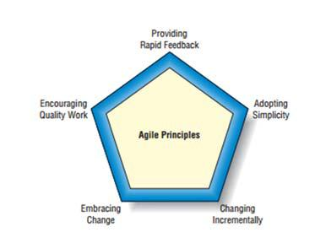Agile processes aim towards sustainable development. The developers, and the users are able to maintain a constant pace with the project.

**Figure : Agile Basic Principles. (AGILE MODELING AND PROTOTYPING. (n.d.))**

* **Monitoring:**

Paying regular attention to technical excellence and significant design to enhance agility.

* **Simplicity:**

Agile methods make the system development simple and easily understandable for users.

* **Self-organized Teams:**

As an independent developer for the Online Patient Scheduling System, by following the Agile approach, the developer is able to self-organize the tasks during the system development and implementation.

* **Review the Work Regularly:**

Reviewing the work done at regular intervals in order to produce a more effective system and adjust its behavior accordingly.

4.5 Agile Methodologies

There are several methodologies that could be implemented during the Online Patient Scheduling System. Agile Methods are focused on different aspects of the software development life cycle. Though few of the Agile methods are practice centric such as Extreme Programming, Pair Programming, others focus on software projects such as the Scrum Approach.

4.5.1 Scrum Approach for Online Patient Scheduling

Among several methods available in Agile Methodology, the developer has chosen the Scrum Approach to develop the proposed system. Scrum is one of the most widely used Agile Methods. Ken Schwaber first described Scrum in 1996 as a process that “accepts that the development process is unpredictable,” formalizing the “do what it takes” mentality, and has found success with numerous independent software vendors. In the Scrum process, a project management is wrapped around a software development methodology. This methodology is flexible and based on incremental software development processes. In Scrum Approach, the entire development cycle is divided into a series of iteration where each iteration is named as a sprint. There are three main artifacts produced by Scrum method, Product Backlog, Sprint Backlog and Sprint Burn-down chart.

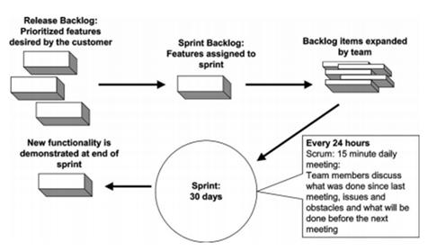

**Figure : Scrum Methodology Overview. (COHEN, D., LINDVALL, M. and COSTA, P. (2004))**

**Product Backlog:**

It is an evolving, prioritized queue of business and technical functionalities that need to be developed into the system and defects that need to be fixed during the release

The Product Backlog contains a unique identifier for each requirement such as categories, feature, enhancement, defect, status and the estimate for the features. It is kept in a spreadsheet-like format.

**Sprint Backlog:**

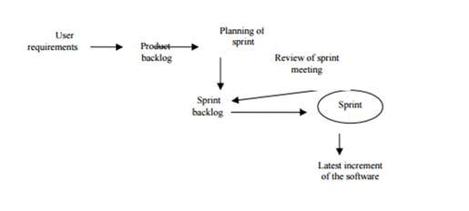This is a list of all technical and business features, weaknesses and enhancements that have been scheduled for an on-going iteration. These lists are known as Sprints. Maximum duration of a sprint is 30 days. Once these requirements are listed, they are broken down into tasks. For each of these tasks in the backlog, the formatted spreadsheet contains a short task description, the origin of the task and who owns the task, the status and the number of hours remaining to complete the task. The Sprint Backlog is updated each day by the developer to determine the latest estimates of the work remaining to complete the task.

**Figure : Scrum Methodology Simplified. (Sharma, S., Sarkar, D. and Gupta, D. (2012))**

**Sprint Burn-down Chart:**

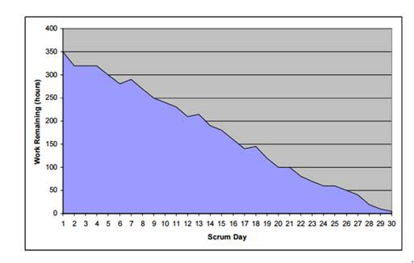A graphical presentation of the hours remaining to complete Sprint tasks. This is a useful demonstration that determines exact calculations of timeline of a sprint.

**Figure : Sample of a Sprint Burn-down Chart. (Williams, L. (2007))**

**Overview of the Scrum Process:**

The Scrum Process is composed of three phases:

**Pre-Sprint Planning:**

Works that are to be done on the system are kept in ‘release backlog’. During this phase functionalities and features are selected from the release backlog and moved to sprint backlog. For the proposed system, user requirements and functions of the system are gathered in the release blog. Then one by one, the functionalities such as user log in, physicians’ list, available time slots, appointment booking, and updating, sending notifications are moved to the sprint backlog.

The tasks in the backlog are generally at a higher level of abstraction, thus pre-sprint planning is able to identify a sprint goal that determines the core and reason of the task.

**Coding:**

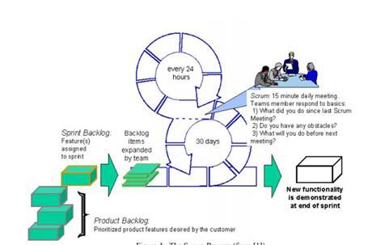During the Sprint-backlog phase, code is integrated for each sprint such as home page log in for users, management portal and physicians’ portal. Next the acceptability of each of these functions is tested daily by the developer.

**Figure : Brief picture of Scrum Process. (Williams, L. (2007))**

**Post Sprint Review:**

After every sprint, a post-sprint analysis would be carried out by the developer to test project progress and demonstrate the functions, design, strength, weaknesses and trouble spots of the proposed system.

4.6 Scrum Implementation:

|  |  |  |  |
| --- | --- | --- | --- |
| **Product Backlog** | **Sprint Backlog** | **Sprint** |  |
|  |  |  |  |
|  |  |  |  |
|  |  |  |  |
|  | |  | |

ONLINE PATIENT SCHEDULING SYSTEM

|  |  |  |  |  |  |  |  |
| --- | --- | --- | --- | --- | --- | --- | --- |
| **1.Log-in** | |  |  |  | Admin User log in |  |  |
|  |  | |  |  |  |  |  |
| **2.** | **System** | | **Change** |  | Admin User Functions |  |  |
| **Control** | | **(For** | **Example:** |  |  |  | 1. Admin |
| **Adding new user to the** | | | |  |  |  |  |
| **system,** | | **updating the** | |  |  |  |  |
| **system)** | |  |  |  |  |  |  |
|  |  | | |  |  | | |
| **3.** | **Log-in, Register** | | |  | Patient User Log in | | |

1. **Department List**
2. **Physician List**

|  |  |  |  |  |  |
| --- | --- | --- | --- | --- | --- |
|  |  |  | Patient User functions | 2. Patient |  |
| **6.** | **Available Slots** | |  |
|  |  |  |  |  |  |
| **7.** | **Book** |  |  |  |  |
|  | **Appointment** |  |  |  |  |
|  |  |  |  |  |  |
|  |  |  |  |  |  |
|  |  |  |  |  |  |
| **9.** | **Update/ Cancel** |  |  |  |  |
|  |  |  |  |  |  |
| **10.** | **Log-in** |  | Doctor User Log in |  |  |

1. **Update Doctor Specification**

|  |  |  |  |  |
| --- | --- | --- | --- | --- |
|  |  | Doctor User Functions | 3. Doctor |  |
| **12. View** | **Patient** |  |
| **Detail** |  |  |  |  |

1. **View Appointment Record**

|  |  |
| --- | --- |
| **14. Log in** | Nurse, Staff User Log in |

|  |  |
| --- | --- |
| **Table 1: Scrum Implementation Table** |  |

4.7 Conclusion:

The prime prevalence of Agile Project Management, especially the Scrum-based approach is its simplicity. One of the major components in Scrum Approach is roles, the Scrum Master. In this project, the developer herself is the Scrum Master who is responsible for self-organization and maintain the product’s progress in a series of month-long “sprints”. The developer will be able to develop, test and organize feature of the Online Patent Scheduling effectively. By focusing on eliminating unnecessary bureaucracy, process and practice in managing the project, Agile methodology will make it possible for the developer to eliminate re-occurring errors and actually finish the project in time.

**Chapter-5**

**Result & conclusion**



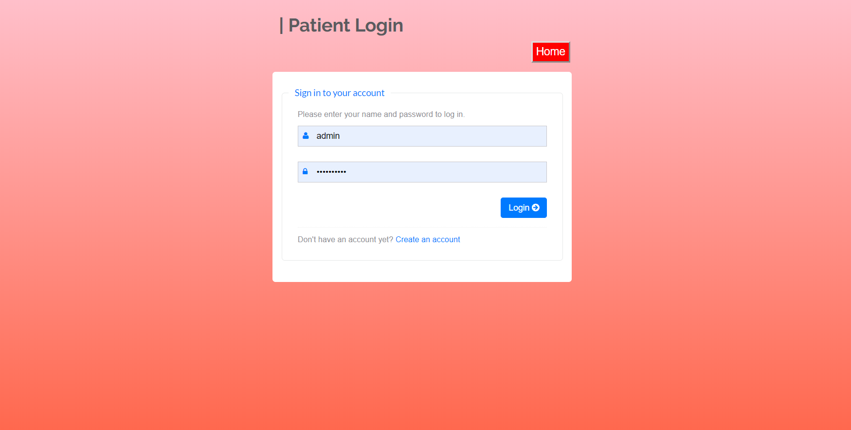

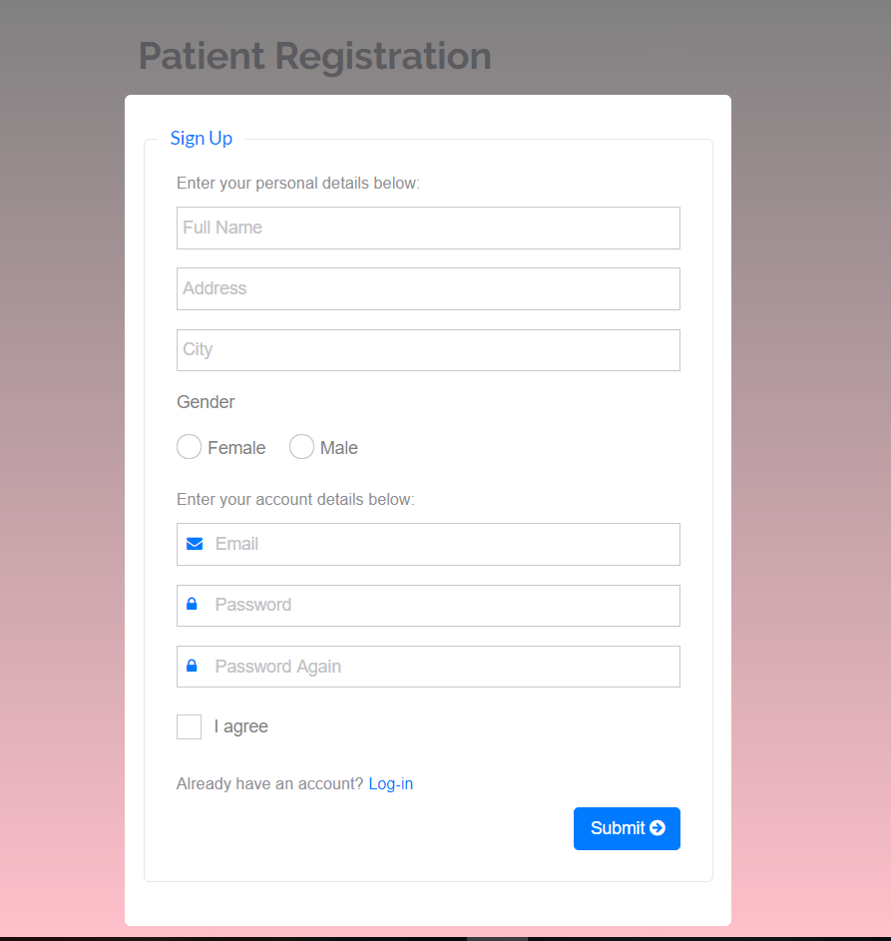

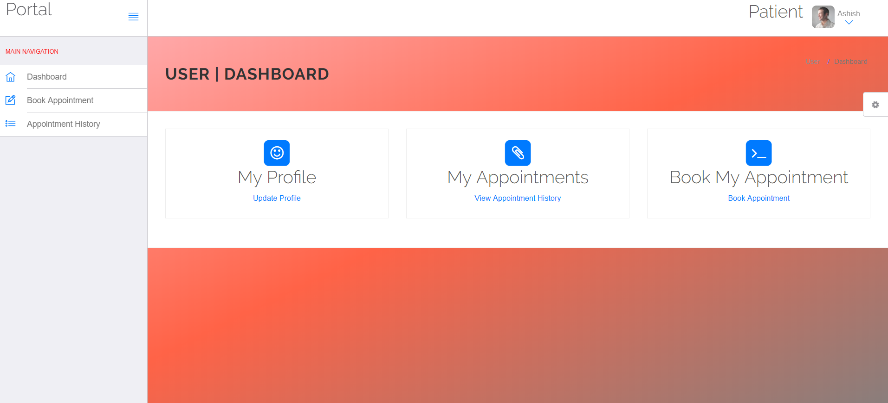

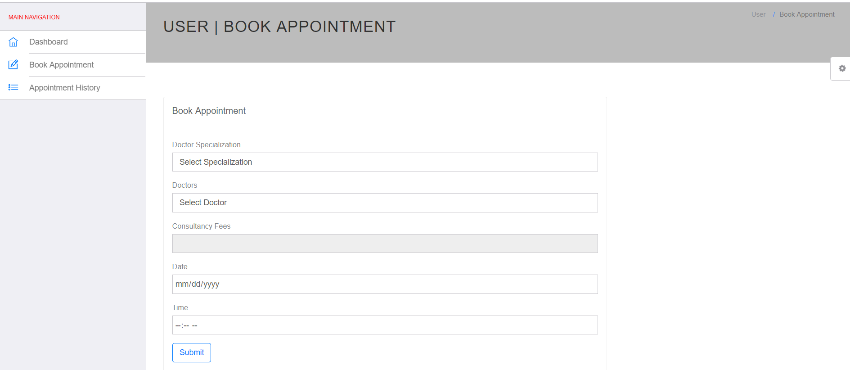

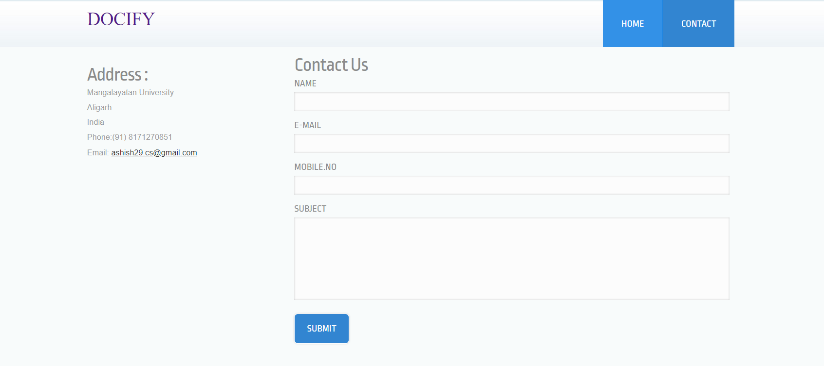

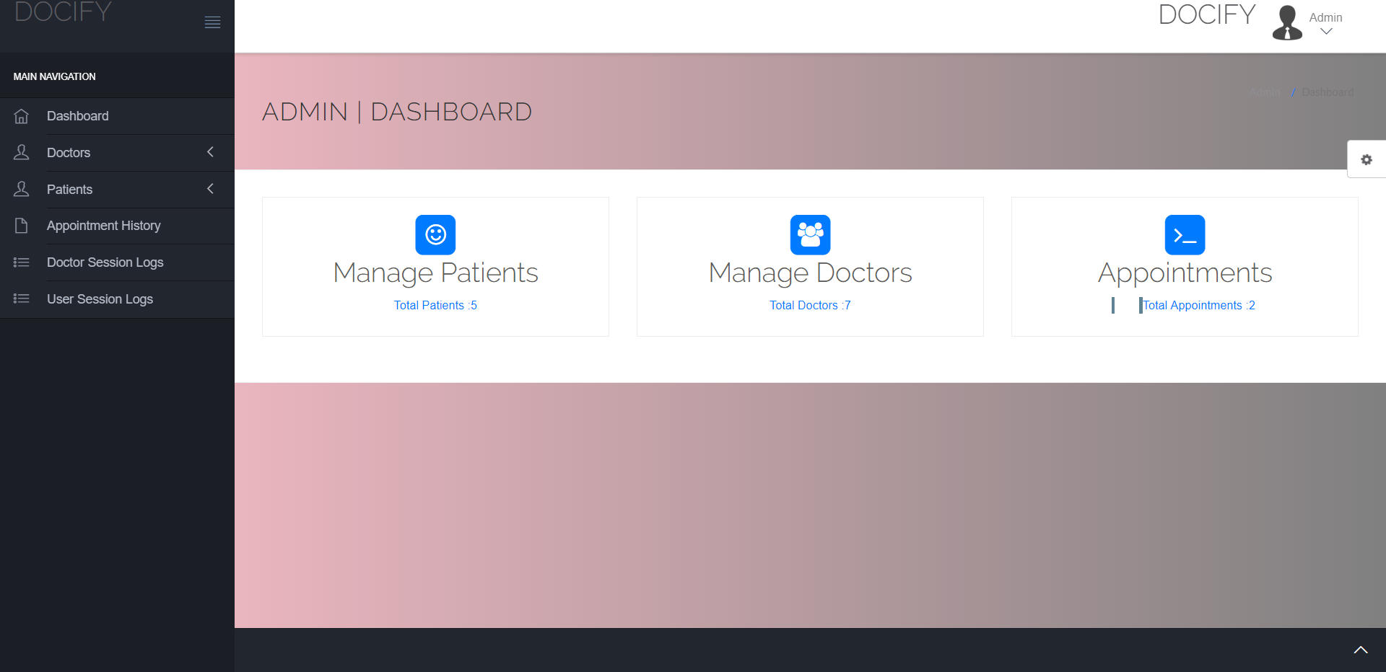

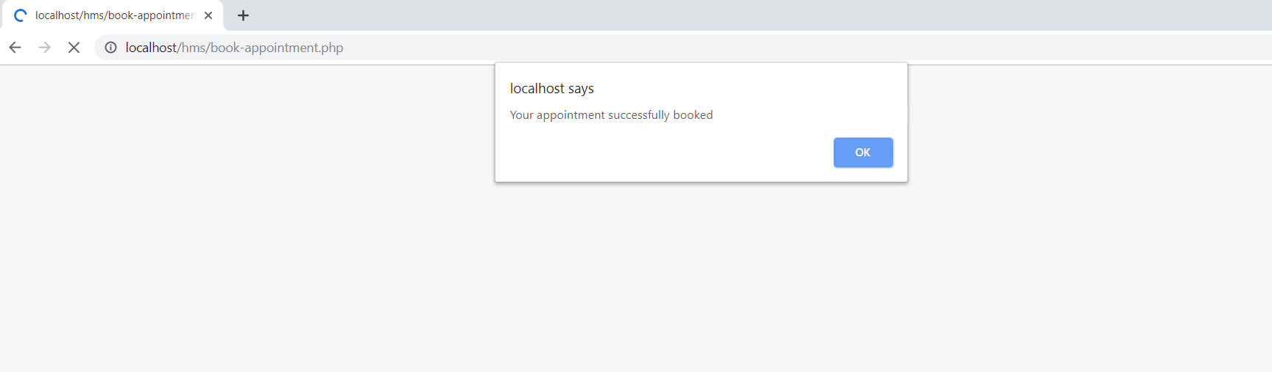 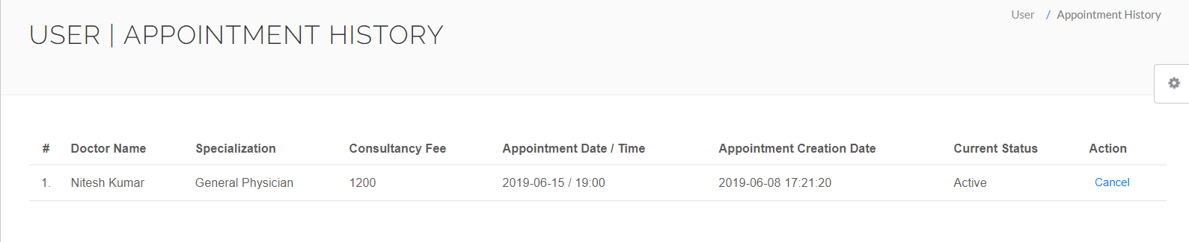

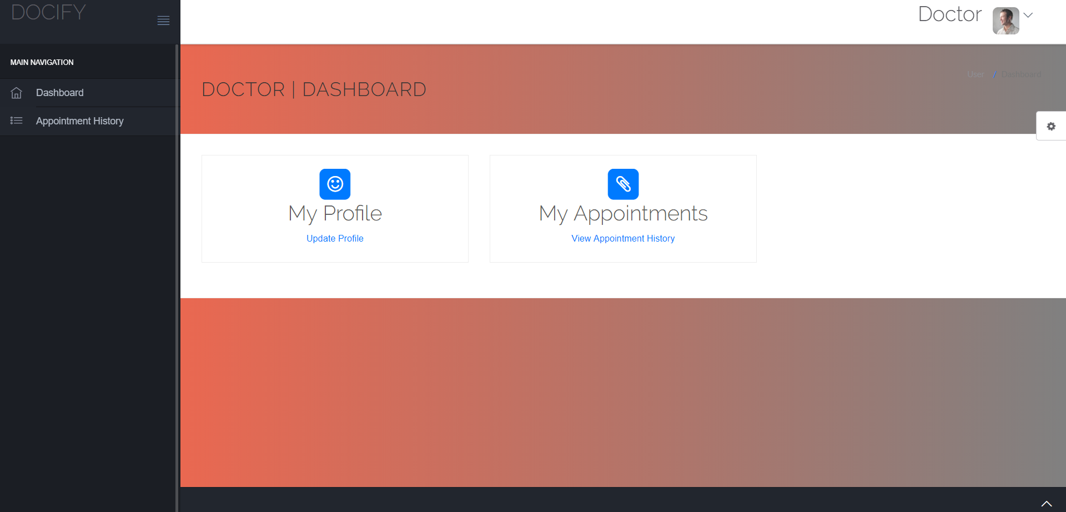

**Conclusion**

The Online Patient Scheduling has been designed and developed aiming to introduce the online platform for medical services in INDIA. The proposed system is the initial base for further more technological enhancements in medical field in INDIA.

During the development phase of the system, the developer has strictly followed time management and has focused on the usage and implementation of the system. The developer’s personal reflection is evaluated down below:

* **Time Management:**

The developer believes in the old saying, “A stitch in time saves nine”. Since the beginning of level 3, the developer has focused on planning and prioritizing tasks. During the two semesters of level 3, initial planning and structure of the system were finalized. Proper time management was implemented in order to manage time for documentation. The developer divided time equally between designing documenting the system. Every improvement made in the program has been documented immediately to assure sync and pattern in the documentation. During the development phase, the developer has prioritized on improving programming skills and web development. Constant evolution of the system has been maintained and documentation has been done with critical specification.

* **Limitations and Future Enhancement:**

One way where the proposed system limits the users is that, the system is a simple online patient scheduling system. Users are allowed to make appointments and make online deposit and the admin is only capable of accessing patient records. The admin is capable registering new staff like nurse and doctors. In terms of such functionalities, the system lacks behind from hospital management system. The Online Patient Scheduling does not generate reports, it only generates appointment status differing from Paid, Unpaid and completed.

* **Importance of the System:**

This project has been a challenging journey for the developer. A brief concept of research has been conducted in order to construct a development framework and a development methodology. From the developer’s perspective, this personal reflection is describing the choices and decisions made

during the development phase. While selecting an appropriate methodology, the developer has looked into several software developer methods and gathered brief knowledge about the concepts. However, majority number of similar system followed the traditional Waterfall Method, the developer has chosen the Agile approach. The simplicity and organized framework of the Agile method would be a great choice for Online Patient Scheduling. A lot of background readings have been done to plan a primary research design.

**Future scope**

**Patient Empowerment:**

One of the biggest reasons that [**Online Appointment Scheduling**](http://www.appointments365.com/) is getting popular day by day is that it empowers the patient to make the appointment to their doctor, clinic or hospital. It makes it a lot easier for the patient to just to go to their computer, access a website or software and make an appointment, than to go to the hospital, wait in a line for a number of hours, just to make an appointment with your doctor for the next week or next month or sometime in future! And through this, patients can also involve in the health decisions that they have to make. They can make an appointment to another doctor other than theirs, by nothing more than a click! The best part of it is that the patient is capable of doing this 24/7 from the comforts of their home.

[**Online Appointment Scheduling**](http://www.appointments365.com/) also helps the providers. The doctor can interact with his patient without the need to call him at his office, saving both patient and provider’s precious time. Scheduling an appointment online is, thus, an effective and a lot less costly way for providers to communicate with their patients. Thus, online scheduling helps both parties. We all know that not all call takers have the best personality on the phone and sometimes you could be making an appointment with a trainee or a fill-in person. With the online appointment, you are always making an appointment with the same level of technology that you are accustomed to. Nothing changes for the worse but for the better.

**Data Sharing:**

Suppose that your provider is too busy to schedule for you an appointment, but you are in need of urgent medical assistance. This could prove to be fatal for you, if the doctor doesn’t send you somewhere else for immediate assistance. This is not the situation where an online appointment will help. You will need to call an emergency number. Providers now will have access to more data that can be shared with other affiliates and entities. To save the patients from terrible experiences like this, online scheduling software allows data sharing amongst providers. We do know that despite the technological advances we have made in the medical field, data sharing amongst providers is way behind. With a system for scheduling appointments, other providers will have access to this data and this will help a patient through a moment of difficulty By sharing the data with other providers, the doctor may direct you towards any other medical centers by just a mere click and nothing more!

**Data Analytics:**

Online scheduling of appointments also gives the providers a big advantage, which is analytics. Once you schedule with your doctor online, all your medical needs will be shared with the other medical providers within the same medical network, so that if you need to go to a bigger and better hospital, you may be told to do so immediately. Some appointment systems can also store all of your medical records, so that it helps the doctors understanding your medical history, which in turn may help you get better treatment from the moment you walk through the door. When a provider has more information before you walk into their office, time and money is saved and   the doctors will be able to attend you confidently and with more answers to you ailment.

**Saving Precious Data:**

Whenever you make an appointment with say your doctor, the doctor only gets to know that a patient with that name is coming to see them today. The doctor may not know anything else without carrying your EMR (Electronic Medical Records) around the office. The doctor may not even   know your medical history. He may not even know your medical problem. He can, at his best, guess what are you going to ask to be prepared for it. All of this lack of information will not make the practitioner prepared. To deal with all of this, an appointment online system can alleviate this undue stress of not knowing and put the focus where it belongs on your treatment. Through this online appointment system, you can fill an information page and tell the doctor your medical history and the medical problem that you are currently facing. This will help the doctor to be far more prepared. In turn, the doctor will be ready to fully attend to you. It will also give the doctor a bit of more time so that they may even do a bit research on how to solve your problem. This will give you the opportunity to have excellent service from the doctor.

**Expenditure Reduction:**

Making an appointment with human involvement can be expensive. We all are paying for this excessive expenditure in medical care. According to a research conducted by DHHS in 2006, a staggering amount of 2.3 million was spent on Health Care in that year. But to the surprise, 1.5 trillion of all that money could have been somehow prevented using cheaper and more efficient ways to interact and communicate with the patients. Appointments alone cost a lot of money. If you calculate the cost of having an administrative person or persons, their full benefits and other overhead cost, this can go over $100,000 annually for one person. We can prevent all of this huge expenditure by simply moving to an alternate method, that being the online scheduling of appointments. It is the much cheaper way and will help both the patient and the medical institute save us a lot of money which we can spend on other important items.

**Making Patients the Spotlight of Attention:**

By making an appointment online to your doctor, you will become their center of attention. They will always know that you are coming and they will be prepared to help you. Making a regular appointment might not get to the doctor immediately. Another great advantage of online appointment scheduling is that the patient can always go online and make changes to their appointments.  But at the comforts of your home, you can easily access the internet and simply make your appointment anytime, saving you a lot of time and effort. You can also make an appointment on the go with your mobile device. A lot of patients and doctors have mobile technology nowadays. A research shows that over 75% of people can access the internet today and have some type of a mobile technology. You can even make an appointment from your car (though not recommended), from a coffee shop or even while watching your favorite movie from your living room.

**Making Patients the Spotlight of Attention:**

With the demographics changing in the US, we have a lot of immigrants who English is not their first language and they need a translator to assist them with making person-to-person appointments. [**Online Appointment Scheduling**](http://www.appointments365.com/) can help bridge that language barrier gap… You can simply use a Google translator to translate the appointment system and feel at least comfortable booking the appointment without human interaction. While this is not substantiated, immigrants might feel comfortable interacting with a technology while making the appointment that feeling comfortable interacting with a human appointment taker. W can say that by making appointments online, we will be saving everyone’s time and money and creating a more convenient atmosphere for both patient and provider. And the patient who has language difficulty can still have access to quality health experience like everyone else, without even the slightest of delays!

**Enhanced Service Quality:**

Many times, mistakes are made by secretaries or the patients while exchanging information. This may trigger a lot of problems for both the patient and the doctor when the patient arrives. Through [**Online Appointment Scheduling**](http://www.appointments365.com/), there’s no such thing as mistakes. You can proofread your appointment a number of times just to be sure. Hence, [**Online Appointment Scheduling**](http://www.appointments365.com/) guarantees a better service quality. You the patient is also guarantee that you will have a piece paper as confirmation and you can even print it or sent it to a family member for record keeping.

**Reduction of Personnel Cost:**

Making person-to-person appointment normally requires a lot of attention and resources. You may have to make a number of calls, go through the Interactive Voice Response (IVR), the secretary has to fill in a number of papers, and do a lot of more activities that have nothing to do with your problem. Also, the hospitals and doctors have to spend a significant amount of money as well on the appointments. This amount sometimes reaches quite an astronomical financial spend. The hospitals or doctors can easily cut their expenditures on the appointment-making by using [**Online Appointment Scheduling**](http://www.appointments365.com/)! It rarely needs any effort from the hospital’s side, as all of the information is filled by the patient himself, and there’s no need for the hospital to do any work about the appointments. According to a study, practitioners and hospitals can save more than one FTE (full time equivalent) which is factored at 160 hours per month.  Thus, they can save on more benefits and other related costs!

**Increased Rewards to Members:**

As [**Online Appointment Scheduling**](http://www.appointments365.com/) helps everyone, practitioners should encourage the members to make appointments online. For example, San Diego’s Department of Motor Vehicles has uses online appointments and displays the wait times between those with appointments and those without appointments. This am sure has helped the DMV and also people seeking to get services from the DMV, saving the tax payers millions of dollars. Also, this, in turn, shows that online scheduling of appointments makes a lot of sense and it is the wave of the future. When consumers are well informed and take control of their time and money, the society benefits and improve.

By all of this, we can finally conclude that scheduling appointments online is a lot faster, cheaper and better way of making appointments. All of us will benefit from this type of a system that is already available is being made popular due to enhancements in technology.

**References**

INTRODUCTION TO AGILE METHODS. (2016). 1st ed. [ebook] Available at: http://www.infoq.com/resource/articles/scaling-software-agility/en/resources/ch01.pdf .

Hypertext Mark-up Language, Introduction. Read 29.10.2018.

<http://www.w3schools.com/html/html_intro.asp>

JavaScript programming language, JS tutorial. Read 03.06.2016.

<http://www.w3schools.com/js/>

MySQL, Open source database. Read 05.06.2016. <https://dev.mysql.com/doc/refman/5.7/en/what-is-mysql.html>

Cascading stylesheet

<https://www.w3schools.com/css/>

Bootstrap tutorial

<https://www.w3schools.com/bootstrap/bootstrap_get_started.asp>

PHP

<https://www.tutorialspoint.com/php/>

Youtube tutorials

Abd Wahab, M., Hassan, N., Wali Mohd, Z. and Hanaf, H. (2009). WEB BASED INTELLIGENT

APPOINTMENT SYSTEM. 1st ed. [ebook] Available at:

http://eprints.uthm.edu.my/121/1/mohd_helmy_abd_wahab_2.pdf].

Dai, X. (2013). Online Clinic Appointment Scheduling. 1st ed. [ebook] Lehigh University. Available at: http://preserve.lehigh.edu/cgi/viewcontent.cgi?article=2467&context=etd.

Mike Benkovich, C. (2016). Online Appointment Scheduling Software for all business - SimplyBook.me. [online] Simplybook Free Online Appointment Scheduling Software System for Web and Mobile. Available at: https://simplybook.me/index/we-are-fit-for